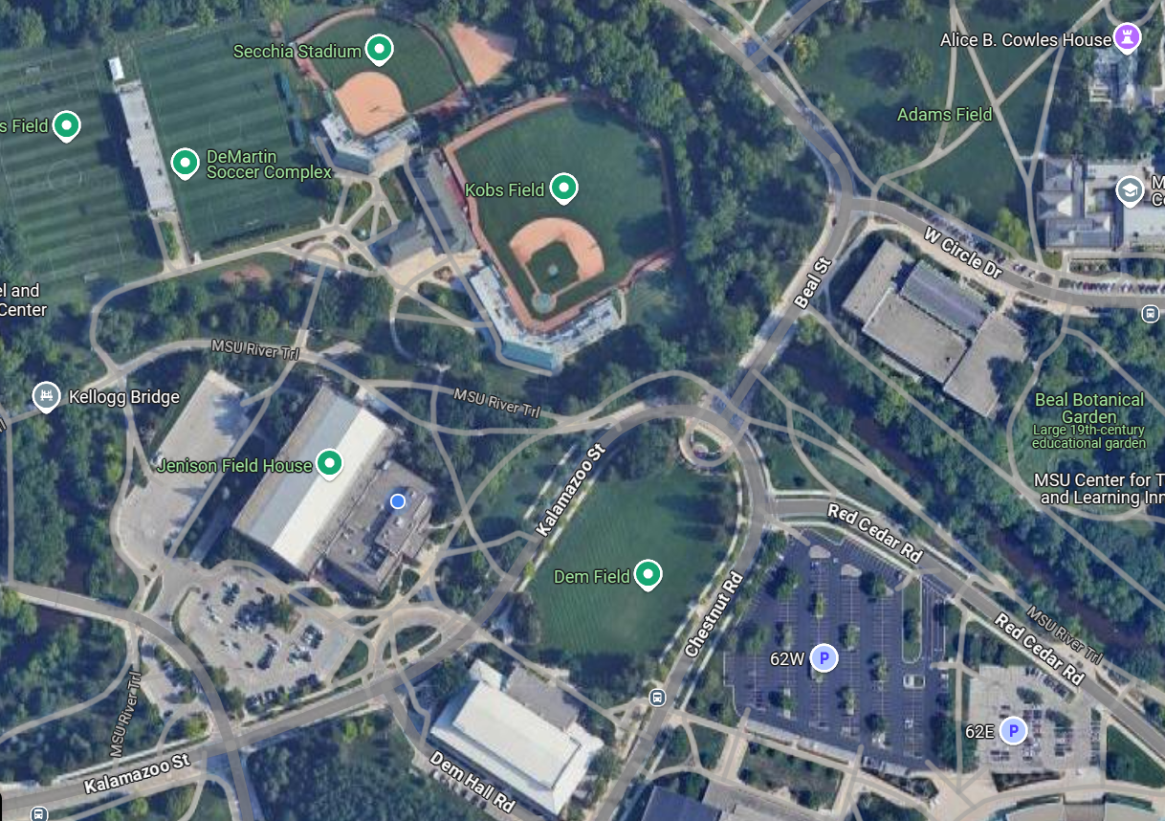

Fan and Spectator Parking for the Ohio State DH on Friday, 3/21/25:

Due to hosting the MHSSA Women’s High School Basketball State Tournament, parking access to the Jenison Fieldhouse Parking Lot (Lot 67) will be restricted to student-athletes and staff. Otherwise, there will be a $5 charge to park in that lot.

All spectators for the softball games are being directed to the IM West Parking Lot (Lot 62W) marked by a star on the above map. There are also directions marked by arrows leading from that parking lot to the front gate where you can access tickets. GPS address for the parking lot is below:

789 Red Cedar Rd, East Lansing, MI 48824